Class Project Phase III – Part 1 Submission Template

Explain your choice for the software architecture and comparison with other alternatives (at least one). This explanation should include benefits of using the software architecture of your choice. Why is it better than the other?

Make sure to include your architecture diagram using the C4 model in your explanation. Your architecture diagram should have two sub diagrams: the context diagram and the component diagram. Ten points extra credit can be earned if you include the deployment diagram in addition to the context diagram and the component diagram. Module 10 has examples of various architecture diagrams and the C4 model examples.

**Length:** This can be 2-3 pages long including the architecture diagram (12 font, single page document).

**Point allocation:** Explanation 7.5 points, Architecture Diagram 7.5 points.

------------------------------------------------Start Your Document Below---------------------------------------

**Architecture explanation and architecture diagram [15 Points]:**

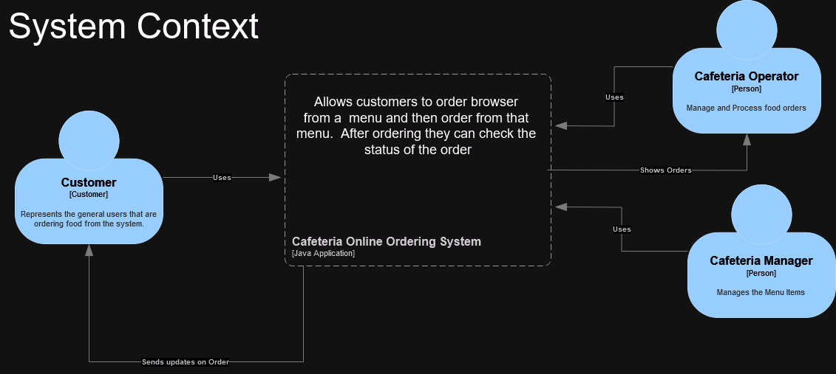

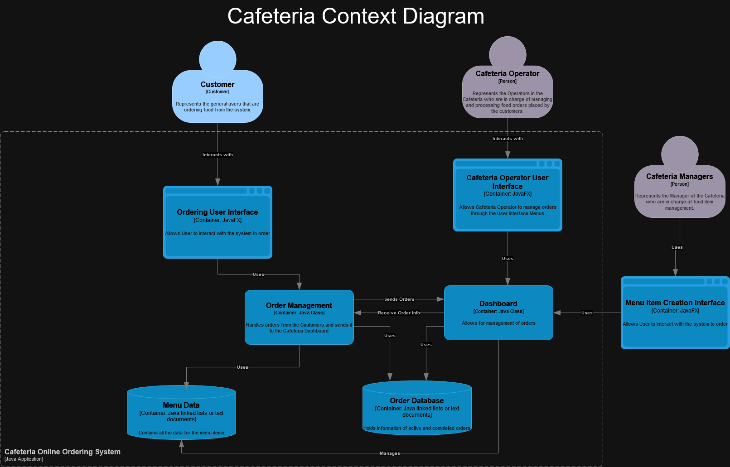

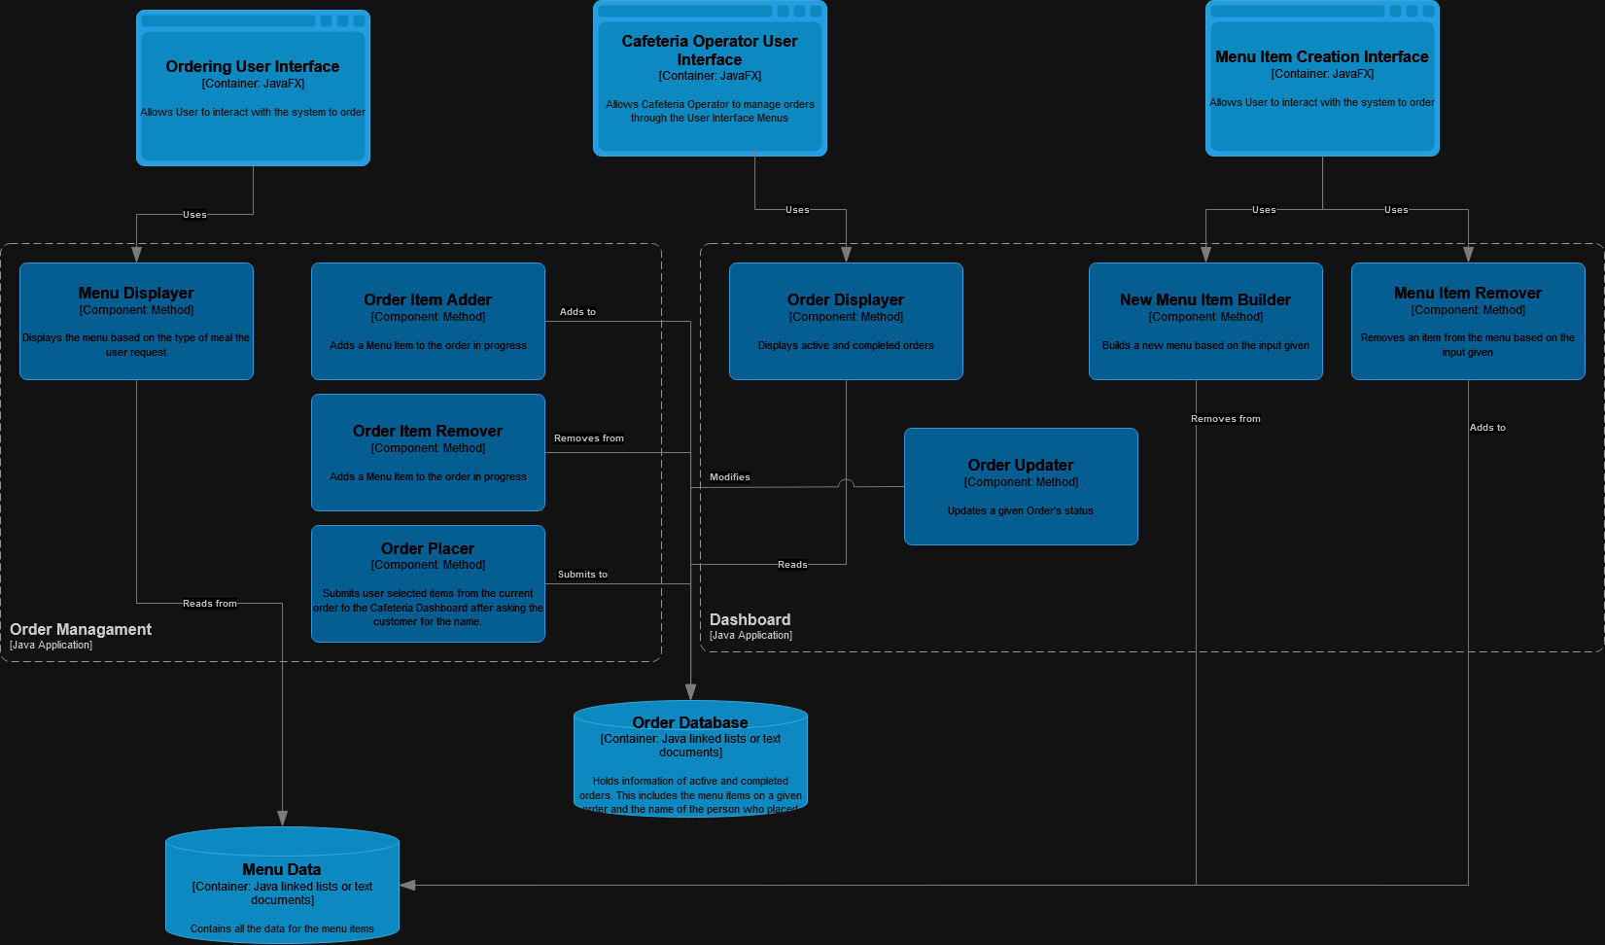

The architecture chosen for the software architecture pattern chosen is the Microservices Architecture Pattern. This pattern allows us to divide up the service that each of the 3 different users need into their own service lanes. For instance we can develop all of the customers' needs in one microservice, the cafeteria operators in another microservice, and the cafeteria manager in a different microservice. This architecture allows us a faster delivery time because we can split up the different microservices to different teams/people allowing for everyone to be working on different projects insteads of everyone working on the same project and potentially running into conflict. This architecture is also scalable because it is loosely defined. We can always for instance add another microservice for a delivery driver by plugging that actor into the system by adding another microservice.

To see why Microservice Architecture was chosen as the software architecture pattern, it will be compared to the Layered Architecture approach. The layered architecture has benefits in its simplicity in the fact that all applications can be split up into layers that can be easily understood because one layer leads to the next layer whereas in microservice architecture the components can be connected in confusing ways. However the reason microservice architecture was chosen was that when working with an application that has so many different uses like food ordering, food status update, menu management, etc. it caused the project to become very cramped and hard to read. For instance if we had an interface layer that layer would have to be responsible for a wide variety of different actors each with their own different needs of Customers, Cafeteria Operators, and Cafeteria Managers. The layers could be useful if these roles shared common interactions with the system. Developing all those different functionalities on one layer would cause the code in that layer to become cramped as the layer would be responsible for a lot.

**Phase I code [10]:** Please upload the code you have developed for this phase into [the google drive and copy and paste the link.

**Video Link [5]:** Prepare a 3-5 minute video explaining your implementation and dome phase I implementation. Upload it to YouTube or any online repository and provide the link.